# Plotly and Cufflinks

## Introduction

* Plotly is a library that allows you to create interactive plots that you can use in dashboards or websites (you can save them as html files or static images).
* Cufflinks connects plotly with pandas

import pandas as pd  
import numpy as np  
import matplotlib.pyplot as plt  
from plotly.offline import download_plotlyjs, plot, iplot  
import plotly.offline as ply  
import cufflinks as cf  
cf.go_offline()  
  
df = pd.DataFrame(np.random.randn(100,4),columns='A B C D'.split())  
df2 = pd.DataFrame({'Category':['A','B','C'],'Values':[32,43,50]})  
  
ply.plot(df.iplot(asFigure=True))  
plt.show()

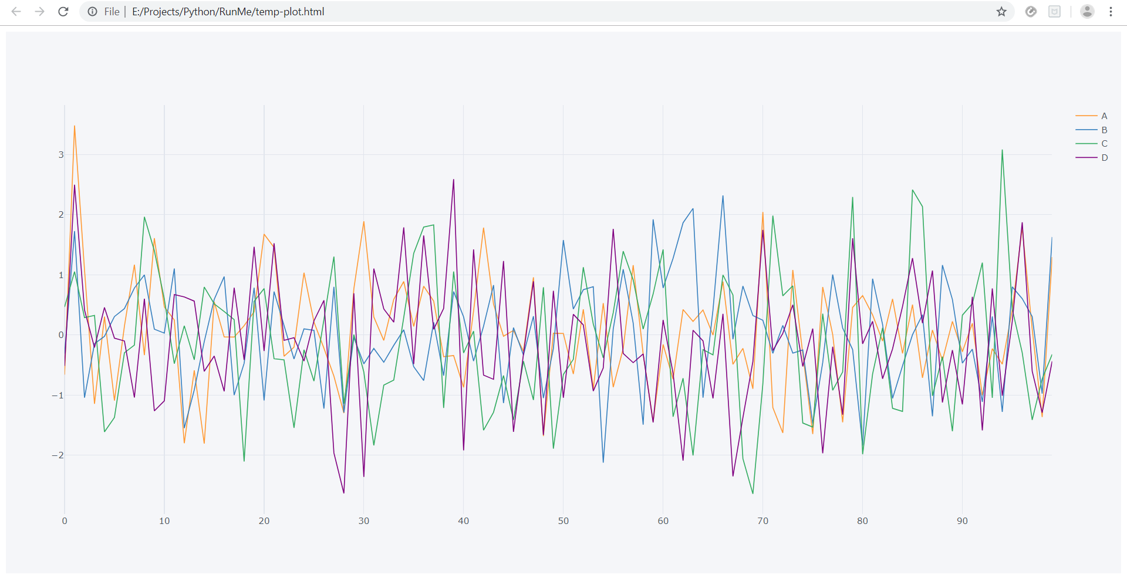

We can see the plot is generated using html in the browser and plot is quite interactive.